23CSE111 OBJECT ORIENTED PROGRAMMING
------------------------------------------------------------------------------------------------
S2 B.Tech CSE
------------------------------------------------------------------------------------------------
Department of Computer Science and Engineering
Amrita School of Computing, Amritapuri Campus
------------------------------------------------------------------------------------------------
CASE STUDY
------------------------------------------------------------------------------------------------
PHASE – 2 (Design)
Architectural Modelling (CO2)
--------------------------------------------------------------------------------------------------------------------------------------

Group No : C13
Team Members :
Roll No | Student Name
AM.SC.U4CSE25209 | BYN.Siddharth Sai
AM.SC.U4CSE25258 | V.Gowtham Adithya
AM.SC.U4CSE25263 | K.Rama Sri Surya
AM.SC.U4CSE25264 | K.Sai Santhosh

- Problem Title : Recover Ease: Lost and Found Item Reporting System

STRUCTURAL DESIGN
- Class diagram (draw class diagram that shows different classes and their relationships. Use UML notations)
The system follows a simple controller-based architecture where the RecoverEaseSystem class acts as the central manager of all operations.
- Item is an abstract base class that stores common attributes such as id, title, description, location, date, and contact details.
- LostItem and FoundItem extend the Item class and provide specific implementations of the display method.
- The system maintains a collection of items using a List, which acts as the in-memory database.
- RecoverEaseSystem handles all core functionalities including adding records, searching, deleting, displaying, and matching items.
- Data persistence is achieved using ObjectOutputStream and ObjectInputStream, storing records in a .dat file.
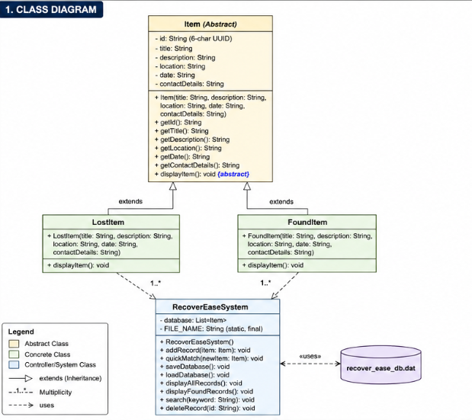

BEHAVIOURAL DESIGN
3. Use-case diagram
a. List of actors
User: Any individual using the system to report, search, or manage lost and found items.

b. List of use-cases
- Report Lost Item: User enters details of a lost item and submits it to the system.
- Report Found Item: User enters details of a found item.
- View All Records: User views all stored lost and found items.
- View Found Items: User views only found item records.
- Search Records: User searches items using keywords (title or location).
- Delete Record: User deletes a record using its unique ID once resolved.
- Auto-Match Records: System automatically checks for possible matches when a new item is added.
- Persistent Storage: System automatically saves and loads data from file storage.

c. Use case diagram (use UML notations)
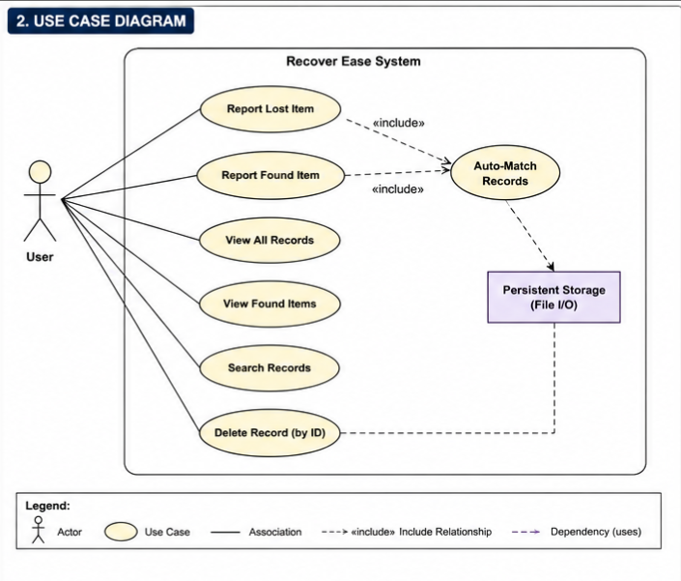

4.Sequence diagram (use UML notations)
  - Choose key use cases and draw their sequence diagram. First describe the scenario in few sentences. Then draw the sequence diagram.
Scenario A: Reporting a Lost Item
A user reports a lost item through the system interface. The system collects the input details and calls the addRecord() method. A new LostItem object is created and added to the database. The system then saves the data to a file and confirms the successful submission.

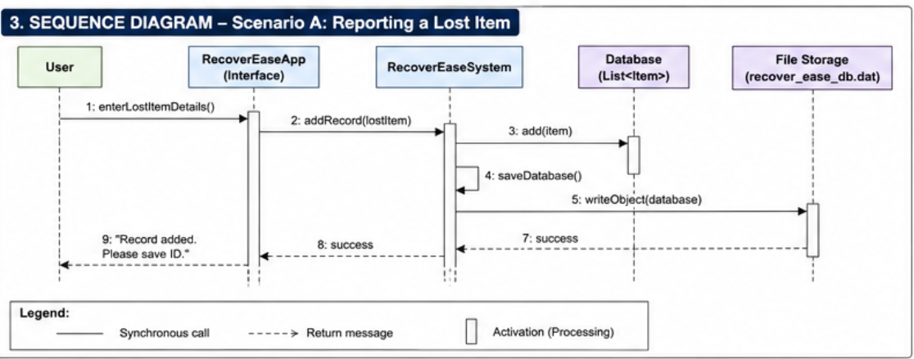

  - Choose key use cases and draw their sequence diagram. First describe the scenario in few sentences. Then draw the sequence diagram.
Scenario B: Matching a Found Item
When a user logs a found item, the system automatically triggers the matching process. The system compares the title of the new item with existing records. If a match is found, it is displayed to the user in the console.

